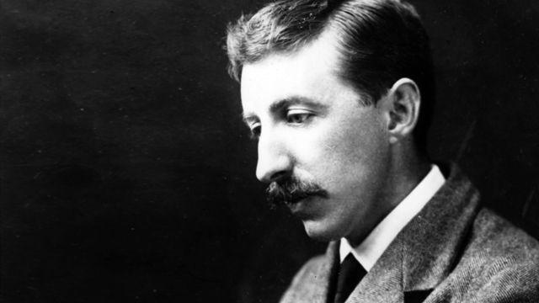**E.M. Forster (1879-1970)**

One of the leading British novelists of the early decades of the twentieth century, Edward Morgan Forster is best known for his novels *Howards End* (1910) and *A Passage To India* (1924). Forster attended Cambridge University where he became a member of the Cambridge Apostles secret society, which brought him into contact with the Bloomsbury Group, including economist James Maynard Keynes and biographer Lytton Strachey. Forster’s work is best remembered for its use of Realism to denounce the repressiveness of Edwardian British culture, and is often infused with Forster’s liberal humanism. Forster was highly influenced by his travels throughout the European continent and India, and his works often illustrate this interest by focusing on settings outside of England. All of the novels published in Forster’s lifetime were published before 1925, after which Forster spent his life working on non-fiction, including biographies, travel narratives, and essays.

**Key Works During Lifetime:**

*Where Angels Fear to Tread* (1905)

*The Longest Journey* (1907)*A Room with a View* (1908)

*Howards End* (1910)

*A Passage to India* (1924)

Forster was born 1 January 1879 into a respectable London family. His father died of consumption in 1880, leaving Forster’s childhood dominated by female figures. After an inheritance allowed Forster a successful childhood education, he obtained bachelor’s degrees in classics (1900) and history (1901) from Cambridge University. Following his graduation, Forster travelled with his mother in Greece and Italy from 1901 to 1907, before returning home to England to lecture at Working Men’s College, London. His travels would influence Forster’s writing – both fiction and non-fiction – as would his service as a Red Cross Volunteer in Alexandria, Egypt and his later trips to India in 1912 and 1921. Forster returned to England in 1921 and remained there until his death in 1970.

Forster’s first novel, *Where Angels Fear to Tread* (1905), takes Lilia Herriton as its main character and shows the influence of Forster’s early travels. Lilia and her daughter Irma travel to Italy, where Lilia falls in love with an Italian peasant named Carella. After being disowned by the Herriton family and realizing her marriage with Carella isn’t what she thought it was, Lilia dies giving birth to Carella’s son. The Herriton family desires to bring the new child back to England and sends Philip Herriton, Lilia’s brother-in-law, to retrieve the child. The baby is killed in an accident before the Herritons reconcile with Carella and return to England.

Forster’s next novel, *The Longest Journey* (1907), was his first major work. This novel, a sort of bildungsroman, takes place in England and is set primarily in Cambridge and Wiltshire. The novel follows the lives of the disabled Rickie Elliot and his half-brother Stephen Wonham. The novel focuses primarily on Rickie’s progression and developing relationship with his half-brother. The novel ends with Rickie’s death while saving Stephen from a train.

His third novel, *A Room with a View* (1908), also emphasizes Forster’s early travels to the continent. This novel focuses on the interactions between the bourgeois family of Lucy Honeychurch and the more progressive family of George Emerson. This novel anticipates the later class analysis that is present in *Howards End*, and illustrates the class conflicts that were common in the early years of the twentieth-century. In the end of the novel, Lucy turns away from wealthier Cecil Vyse and marries the working-class George Emerson.

*Howards End* (1910) gives a more complete view of the social and economic relationships in turn-of-the-century England. The novel follows the Schlegel sisters (Helen and Margaret) and their interactions with the wealthy Wilcox family and the poor Bast family. Helen is drawn to Leonard Bast, whom the Wilcoxes dislike, and becomes pregnant. Margaret marries Henry Wilcox, but leaves him to go to Germany with her sister after the Wilcox family turns their backs on Helen and Leonard. After Henry and Margaret’s son Charles kills Leonard, Helen and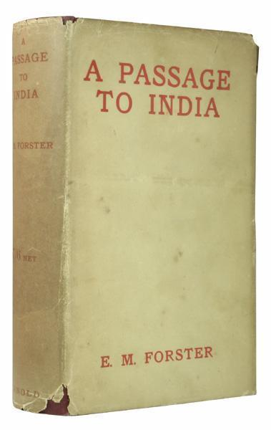 Margaret reconcile with Henry who wills Howards End, the Wilcox family estate, to Margaret. At the end of the novel Margaret claims that the estate will go to her nephew, Helen and Leonard’s son, upon her death.

The last novel published during Forster’s life, *A Passage to India* (1924), is often considered to be his masterpiece. After traveling to India, Forster wrote the novel against the Indian Independence movement. It is loosely based on his experiences. The novel centers on the young Englishwoman Adela Quested’s journey to India to meet Ronny Heaslop, a colonial officer she may marry. In an effort to experience the authentic India, Adela and Ronny’s mother Mrs. Moore visit the Marabar caves with Dr. Aziz, a local physician. Adela accuses Dr. Aziz of sexual assault and a trial ensues. During the trial Adela recants her accusation and Aziz is freed. Critics have celebrated the novel as a detailed examination of the British colonial system and an unmasking of the civilizing mission associated with the British Empire.

After the publication of *A Passage to India,* Forster began to focus his creative attentions on non-fiction, including biographies and historical accounts. His last novel, *Maurice* (1971), would not be published until after Forster’s death. This novel, suppressed because of its homosexual content, follows the coming-of-age story of Maurice Hall and his conflicted feelings about his homosexuality.

Although Forster did not publish a novel in the last four decades of his life, his reputation as a novelist persists. His work *Howards End* remains celebrated for its depiction of the social and economic systems of early-twentieth century England, and *A Passage to India* stands as one of the most canonical English texts for the early-twentieth century and remains an important indictment of the British colonial system. Forster remains one of the most important and influential writers in twentieth century British literature.

-Adam R. McKee

* FORSTER IMAGE URL <http://www.bbc.co.uk/iplayer/images/episode/b00n5vjs_640_360.jpg>